E127 experiment
beam time manual

contacts:
- Laszlo Varga, l.varga@gsi.de, +4917659566492
- Jan Glorius, j.glorius@gsi.de,
- Uwe Spillmann, u.spillmann@gsi.de,
- Christoph Langer, C.Langer@gsi.de,
The digital version of this manual can be found at
https://elog.gsi.de/esr/E127/40

For all DAQ & slow control issues:
litv-exp
ViValasVegas1964

E127 devices

E127 devices:
- VME cpu, r4l-58 (RIO):
  - the main DAQ device
  - located inside ESR, at the end of the 1. dipole, in the middle of the rack
  - access from lxg1275 via ssh litv-exp@r4l-58
the current DAQ directory is /esr/usr/litv-exp/2020_e127/r4l-58
from lxg-machines the DAQ dir can also be accessed via the mount point at /lynx/Lynx/esr/usr/litv-exp/2020_e127/r4l-58
- lxg1275:
  - communication with the DAQ and primary data writing/streaming
  - located in the old “Messhütte”
  - access from any lxg via ssh litv-exp@lxg1275
  - primary data folder: /data.local3/e127/lmd/
- lxg1299:
  - server for online ROOT monitor
  - located in KBW 3.07
  - used for the R3Broot online monitor server
  - access from any lxg via ssh litv-exp@lxg1299
  - online data: /data.local3/e127/online/
- atpnuc004:
  - slow control (epics)
  - inside ESR, at the end of the 1. dipole, in the bottom shelf of the rack
  - used for remote access to SpecAmps (MesyTec Shapers), Si-HV (caen) and picoscopes
  - access from any lxg via ssh litv-exp@atpnuc004
  - screen sessions: mesy_ioc (shapers), caen_ioc (Si HV)
  - access screens by screen -x mesy_ioc or screen -x caen_ioc (exit with [Ctrl-a d])
  - access vnc session for picoscopes on any lxg: E127_vnc or vncviewer atpnuc004:1
- apraspi001:
  - HV control for BaF detectors
  - located inside ESR, close to target
  - access from any lxg via ssh litv-exp@apraspi001
  - local access to HV control by telnet: telnet 169.254.93.160 1527

List of commands and aliases
- E127_daq or /data.local1/e127/scripts/E127_start_gui.sh
this is the GUI to control the DAQ
available on lxg1275 only with litv-exp user
only one instance of this GUI can run at the same time!
- E127_unpack or /u/litv-exp/unpacker/unpackexps/e127/e127
this is the unpacker for the current DAQ
available on any lxg with litv-exp user
to unpack lmd-files to root-file:
E127_unpack infile01.lmd infile02.lmd --ntuple=RAW,outfile.root
- E127_epics or epicsfind; medm -x /u/litv-exp/e127/medm/e127.adl
this is the GUI for slow control of Si HV and amplifiers (MesyTec Shapers)
available on any lxg with litv-exp user
- E127_rates or /u/litv-exp/e127/UDP/build_cc_x86_64-linux-gnu_4.9.2_debug/udp_reader --trig --rate
this is the UDP reader for detector and trigger rates
available on lxg1275 only with litv-exp user

Data folders for the experiment data (lmd files):
- original lmd: lxg1275: /data.local3/e127/lmd/, backups in each hour
- 1st backup: lxg0188: /data.local, backups in every two hours?
- 2nd backup: luster
- onlineROOT: /data.local3/e127/online/

DAQ-GUI

start a DAQ GUI

log into
ssh litv-exp@lxg1275.gsi.de -Y
go to:
cd /data.local1/e127/scripts
start gui:
python e127_gui.py

???

ONLINE (R3B) ROOT

Start and stop the server for online monitor

Log into the lxg1299 mashine as litv-exp:
ssh litv-exp@lxg1299.gsi.de -Y
go to:
cd ~/R3BRoot
start online ROOT
./start_onlineROOT_E127.sh
Then on any mashine within GSI the online monitoring can be opened from a browser at the following address:
http://lxg1299:5679

To stop the online monitoring hit only once the Control+c combination. The histos get saved automatically in the local disk. The file numbering is set to incremental by default.

Please start and stop the server in each hour once to avoid large files. Also, most of the histos has the “memory” of 1 hour.

When starting a new server please check if opening the http port went fine. If it is alright in the upper part of the header text you should see:
Info in <THttpEngine::Create>: Starting HTTP server on port 5679
If some problem appears to open the port see the next next chapter 3, point.

Interface of the online monitor

After opening the webpage of the online ROOT please monitor frequently the first two sheets.
You can open them by clicking into “Canvases” and then:
1. canvas: for_Shifts_RATES
2. canvas: for_Shifts_SI_and_XRAYS

1.canvas
- Upper row: 2D position histograms of the DSSSD hits. Hits are accepted if they are between the LOW and HIGH energy threshold. “No double counting” means, that for each event only one hit with the highest amplitude is filled into the histogram in order to avoid the counting of the same ion hit multiple times (eg.: charge sharing between strips).
The beam is located optimally at the x=-8 strip position.
On the TargetON histo hopefully we should see Rutherford scattering (decreasing tail from left to right) and the p-capture peak centered in the detector.
On the TargetOFF histo hopefully we wont see any structure.
- Middle row: energy spectra of the X-ray detectors surrounding the Gas jet target at 35°, 90° and at 145°.
The blue curve measures the spectra when target on → expected real atomic spectra (Kalpha, Kbeta, Lapha …)
The red curve measures the background → expectedly no peak structure
- Bottom row: the energy of the 2. Xstrip (closer to the beam) and the 8. Y strip (middle strip) of the Si detector are shown as a function of the event number of targetON. Every (5*avg_sampling_time)^{th} event (without averaging) is plotted.

2. canvas:
- Left column: raw Si rates for X and Y sides (any strip on one side has signal above threshold generates a count), raw Xray rates, and only raw BaF1 rate (only the 1. BaF is connected to the vulom scaler).
Take care that the rates remain roughly constant over time.
- Right column: DSSSD bias voltage and current, ESR current and the uncalibrated target density
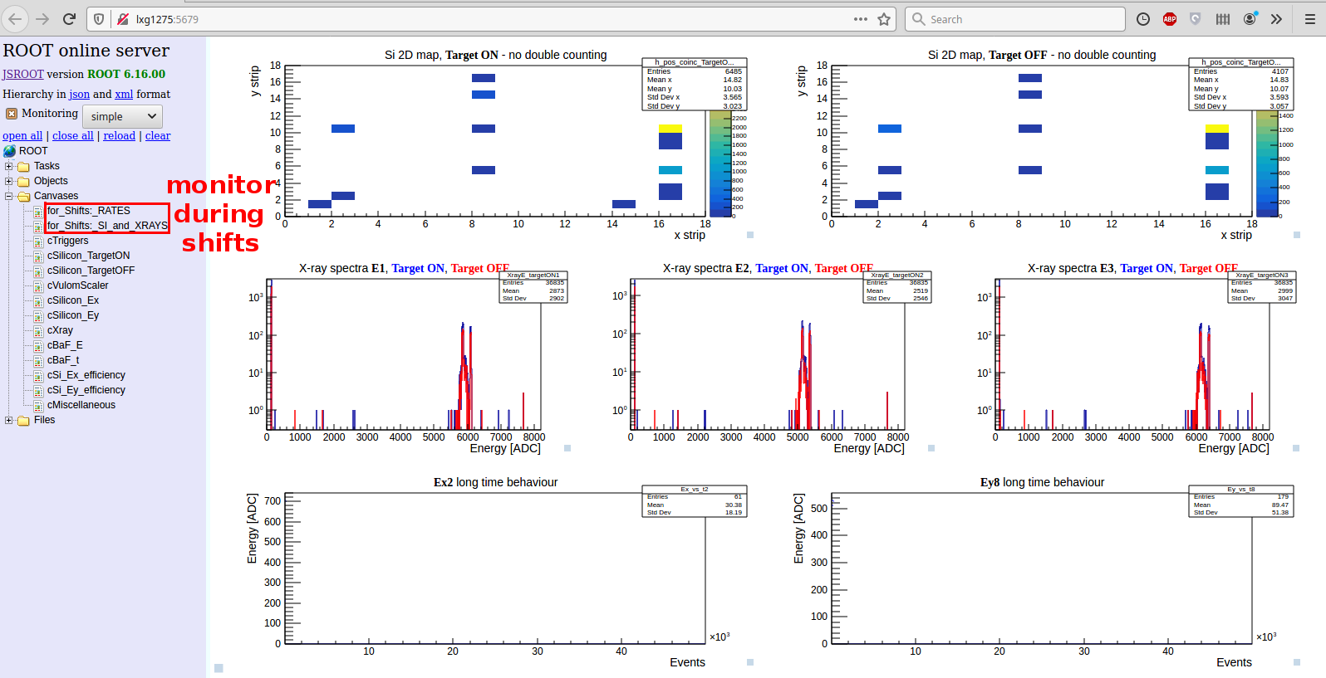

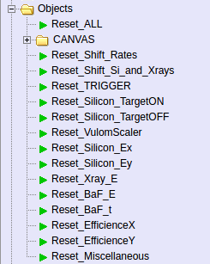
Using the “Objects” button you can empty the histograms:

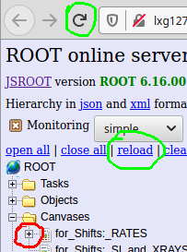
If you double click on the histogram, it opens up and you cannot review it later on. To correct this either refresh the webpage (F5) or click on the “reload” icon above.

Simple adjustments

To set the
1, low and high energy thresholds for all silicon channels (for the 2D position histos)
2, the average sampling time for the Tgraph-s
3, http server port

modife only the “online.C” file. This does not require to compile all the online ROOT package.
nano ~/R3BRoot/macros/r3b/unpack/e127/online.C

1, set an integer for the low and high thresholds:
r3bOnlineSpectra->SetSiThreshold_LOW(500);
r3bOnlineSpectra->SetSiThreshold_HIGH(8000);

2, set an integer for the TGraph sampling time
r3bOnlineSpectra->SetAvgTime(20);

3, set up a http server port
by default the port is set to 5679:
run->ActivateHttpServer(refresh,5679);
It can happen that when closing the online monitor, the port doesn't closes well(for example instead of “Control+c” you have to use “Control+z”). There are two complementing ways to solve the issue:

a, kill the running online monitor from bash:
pgrep -f online.C
in normal case two PID number will appear, let's name them PID1 and PID2.
Alternatively, for more info, this command can be also used:
ps aux | grep online.C
Kill the processes related to online.C
kill -9 PID1
kill -9 PID2
Now you can restart the online server again.

b, use a different port:
set a new 4digit number for the http port in the online.C file:
run->ActivateHttpServer(refresh,new_integer);
However, in order to not to overload the server first try point a,

Massive adjustments

Here is the collection of the most important files for the online monitor. Before changing something, please don't forget to backup!

- For starting a server and small/quick adjustments:
nano ~/R3BRoot/macros/r3b/unpack/e127/online.C

- Histos, canvases are defined here:
nano ~/R3BRoot/r3bbase/R3BOnlineSpectraE127.cxx
nano ~/R3BRoot/r3bbase/R3BOnlineSpectraE127.h

- Data structure file created by using the unpacker:
nano ~/R3BRoot/r3bsource/ext_h101_e127.h
To create a new data struct file:
cd ~/R3BRoot/r3bsource/
mv ext_h101_e127.h ext_h101_e127_backup.h
cd ~/unpacker/unpackexps/e127
./e127 –ntuple=RAW,id=h101_e127,exp_h101_e127.h
nano exp_h101_e127.h
delete all the “*/UNPACK*/” sections from the text file (occurs ~3times), then copy it to the source folder:
cp ext_h101_e127.h ~/R3BRoot/r3bsource/

- Data mapping for the online:
nano ~/R3BRoot/r3bdata/e127Data/R3BE127MappedData.cxx
nano ~/R3BRoot/r3bdata/e127Data/R3BE127MappedData.h

- Read variables (energy variables, rates, …) used for the canvases:
nano ~/R3BRoot/r3bsource/R3BE127Reader.cxx
nano ~/R3BRoot/r3bsource/R3BE127Reader.h

DETECTOR READOUT AND DAQ
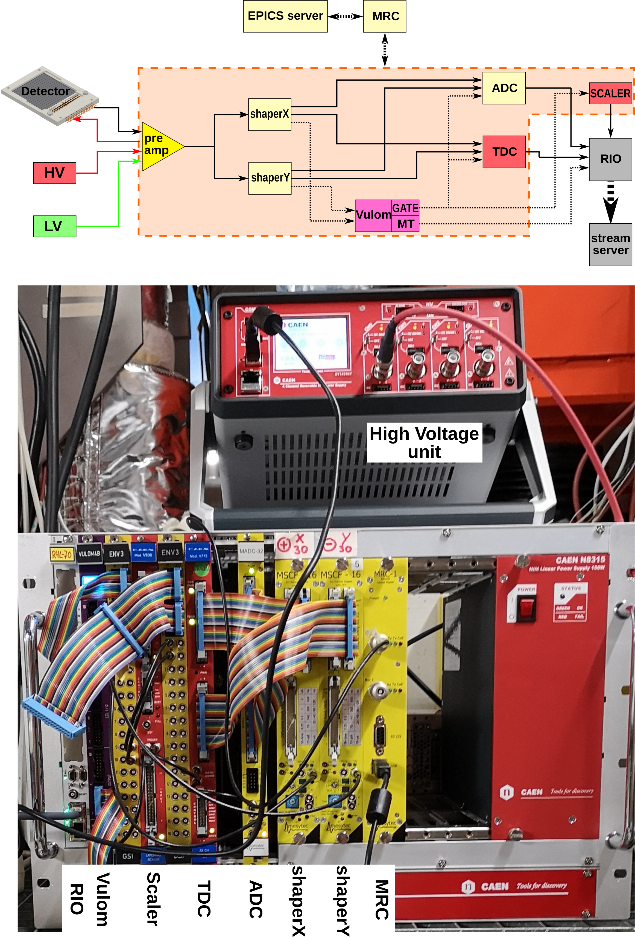
Linux “screen” main commands

Linux screen is basically a virtual terminal with many useful applications... Just as a refresh, here are its main commands:

screen -ls - lists sessions
screen -S session_name - creating a new screen session
screen -x session_name - attach to screen sessions
screen -X -S session_name quit - kill session

inside a screen session:
Ctrl+a c - create a new window
Ctrl+a 0 - switch to window 0
F3 / F4 - switch to left/right window
Ctrl+a d - detach from screen

SLOW CONTROL

Start the EPICS server and HV of DSSSD

In most of the cases the server is already running, before trying to start the server, please check the next Section.
Log in the litv-exp@atpnuc004 computer
ssh litv-exp@atpnuc004 -Y
go to:
cd ~/epics/e127_ioc
start a screen session
screen -x mesy_ioc
start epics server
./bin/linux-x86_64/mrcc iocBoot/iocmrcc/start_e127_ioc.cmd
while starting in optimal case there are no red text
the normal popping up messages eg.:
cbLow: Process e127pi:mrcc:mscf2:getShaperOffset
where:
e127pi = where the EPICS server is running (mistakenly written “pi”)
mrcc = a module communicates between the hardware units (eg. shapers) and the computer
mscf2 = shaper id
getShaperOffset = an object which has functions like "get" and "set"

Also switch on the HV of the DSSSDs
screen -x caen_ioc
???

User interface for slow control (EPICS)

Log into any litv-exp@lxg computer, for example:
ssh litv-exp@lxg1247.gsi.de -Y
first attach the EPICS enviroment
epicsfind
open a graphical interface for slow control:
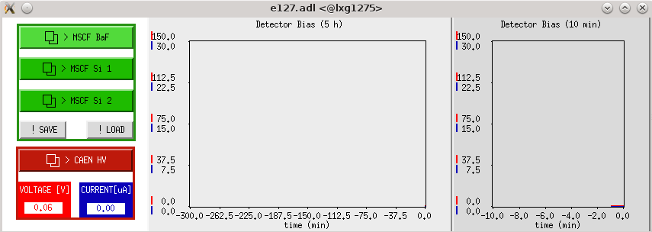
E127_epics

On the left one can click to operate the Shapers and the HV device. On the right you can see a Si detector HV monitor for long and for short range of time.
On the left klick on “MSCF Si 1” for the Si Shaper 1 (shaper y?), “MSCF Si 2” for Si Shaper 2 and “MSCF BaF” for the BaF detectors. The following window will pop up:

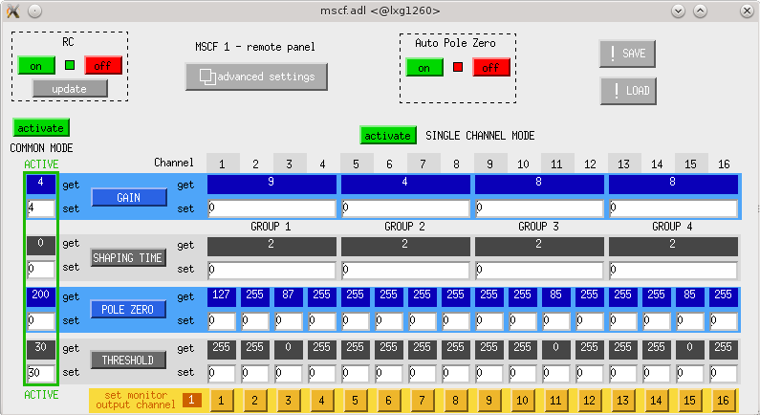
After opening the window, if the server is running one should see variables instead of white, empty fields. If the server is not running please take a look at the previous Section.

On the top of the window:
RC stands for “remote control”. In order to remotely operate the unit a green indicator should appear.

Auto Pole Zero

On the bottom one can active COMMON MODE or SINGLE CHANNEL MODE . The selection is indicated with a green frame around the variable fields. One can set:
GAIN = amplification of the preamp signal. The gain factor has a range of [1;15]. Each stage means a 1.22x amplification. Important, that by changing the gain the level of threshold does not scale up → while changing the gain one has to set the thresholds accordingly.
SHAPING TIME = how long is the preamplifier signal integrated. It has a range of [0;3]
POLE ZERO
THRESHOLD = One can set a threshold to the shaper: when there is a preamp signal above it a trigger is sent from the shaper. It should be set just above the noise: to record also low energy signals, if there is any (during experiment this is not expected). Range [0;255]

Advanced setting
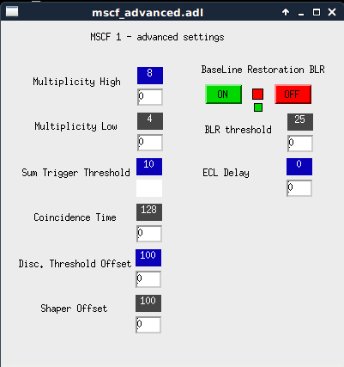

CAEN HV
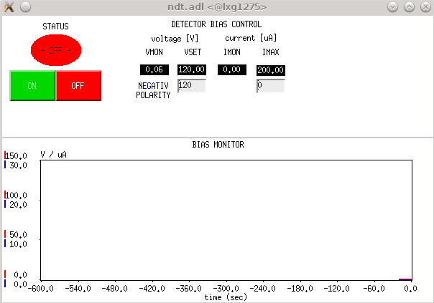
PICOSCOPE

Start a scope view

The online view of the shaper's energy signal and the shaper's trigger signals are done by using a Picoscope (digital oscilloscope).
To open a picoscope view one has to open a vnc viewer which connects to the "atpnbg004" NUC computer. First, check if the vnc server is running on the NUC (atpnuc004):
ssh litv-exp@atpnuc004 (NUC)
vncserver -list
the output should look like
TigerVNC server sessions:

X DISPLAY # PROCESS ID
:1 13765

exit from the NUC:
exit

if not running, start a new:
vncserver -localhost no :1
or
vnc_start

attach to the vnc server on any litv-exp@lxgxxx computer:
vncviewer atpnbg004.gsi.de:1
within the window open a linux terminal (Applications->System->LXTerminal):
picoscope
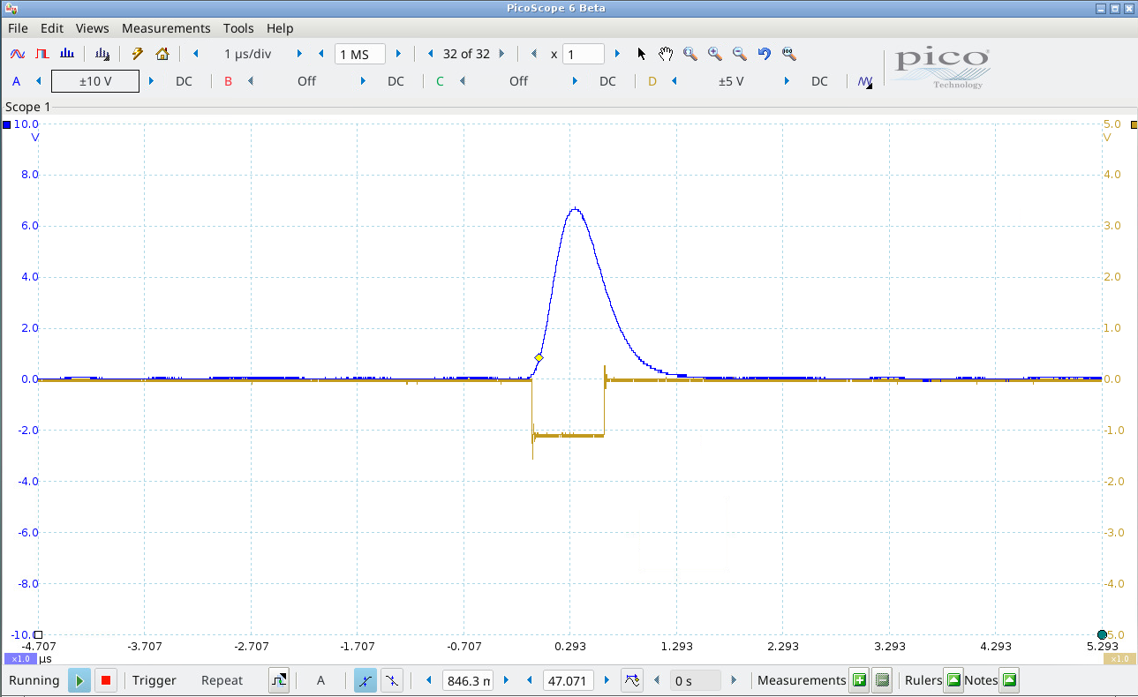

The channels of the picoscope currently (WARNING: might be changed in the future)
Channel A: Shaper1 Eout
Channel B: Shaper2 Eout
Channel C: Shaper2 trigger out
Channel D: Shaper1 trigger out

Suggested scales: +/-10V range for signal, +/-5V, +/-2V range for trigger, 1us/div

Three things should be checked:
1, if the shaper output signals can fit into the voltage range of the ADC
2, find the correct thresholds of the shapers
3, if the gate signal is long enough → if it contains the maximum of the peak

1, use the persistence mode of the picoscope (top left, 2. symbol): there should be no signal on channel A or B which is out of range.
-preamplifier output: [0V;1V]
-shaper output: [0V;10V] at 1kOhm

One should aim that the highest signal appearing should be in the ~2/3 of the ADC voltage range. By quick measurement: 5.45V translates to 6065ADC channel.

If some signals are out of range or to low:
-decrease/increase shaper gain → This can be done in the E127_gui. Important to change also the trigger levels after changing gain settings. The trigger levels don't scale with the gain.
-adjust ADC range, if necessary (main.cfg in R4L-70). Most probably no one has to touch this option.
-change shaper time if necessary. Most probably no one has to touch this option.
To crosscheck if we are recording the whole spectrum, one can make a quick data taking. If the there is a standing out peak with 1bin width in the energy spectra at channel ~7000-7500 → signals are out of range.

2, on the picoscope there should be checked Channel A which is the shaper E_out and the corresponding trigger signal.
-In optimal case, for each signal a trigger should be generated and no trigger for the noise.
-If the threshold is too low and hitting the level of the pedestal → triggers while “no physics” signal → recording noise, which can mess up the deadtime.
-If the threshold is too high → low energy signals are not recorded → not complete spectrum. However, during experiment this is not a super big issue since signal_ionhit >> signal_noise

(DATA RECORDING manually)

How to check if the datastream is ON?

log into the litv-exp@lxg1275:
ssh litv-exp@lxg1275 -Y
attach to the screen server (screen = virtual terminal):
screen -x testDAQ
0. tab: running data acquisition
./start.sh
1. tab: logger
./logger.sh
2. tab: rate monitor:
./rate.sh
3. tab: data stream:
empty_70

How to record data?

on any litv-exp@lxgxxx:
cd /data.local1/e127/pre_data
(~/unpacker/unpackexps/test/test

How to set values of the DAQ modules?

Like ADC_range, ADC_resolution, common start/stop of the TDC, time_range of the TDC, etc... for VULOM, MADC, TDC, SCALER units
cd /lynx/Lynx/esr/usr/litv-exp/esrdaq_2018/r4l-70
nano main.cfg
change between stream server or transport server:
nano start.sh

